Abstract:-
Background – Adults nearly one in five have osteoporosis in India.
Objectives - to study the use of biologicals and conventional therapies in the management of osteoporosis
Materials and methods – A prospective study was conducted in Mumbai. The survey focused on the question of the management of osteoporosis for physicians.
to study the use of biologicals and conventional therapies in the management of osteoporosis
Results – Fewer doctors uses the denosumab than the teriparatide,calcium and the vitamin D3 are the common conventional therapies used by the doctors
Conclusion – Management of osteoporosis in mumbai region anong's the physicians was found to be balanced integrating both conventional and the biologicals

Introduction –
Osteoporosis: The Brittle Bone Disease is “The condition in which the bone becomes weak and brittle”
“Osteo" means bone and "porosis" means porous. So, osteoporosis translates to "porous bone."
The World Health Organization defines osteoporosis as a T score less than <= 22.5
Osteoporosis can also be defined clinically as the presence of a low trauma fracture with or without BMD in the osteoporotic range.
A mechanistic definition of osteoporosis is a skeletal disorder characterized by compromised bone strength predisposing a person to an increased fracture risk.
The recent study shows that the prevalence of osteoporosis was 10.4% for men in <52.2 years category and 18.6% for men in more than 52.2 years category. In premenopausal women, the prevalence was 3.5%, 18.4% in postmenopausal women <5 YSM and 37.3% in postmenopausal women more than 5 YSM. Osteopenia was 35.1%–43.8% in men, 31%–34% in premenopausal women and postmenopausal women <5 YSM and 42.2% in postmenopausal women more than 5 YSM. At the hip, the prevalence of osteoporosis was 5.2%–6.2% in men, 2.6% in postmenopausal women <5 YSM and 16.5% in postmenopausal women more than 5 YSM. A higher prevalence of osteopenia was observed in men (50%–62%) and postmenopausal women (50%–59%) while for premenopausal women it was 32.6%.
Fractures and their complications are the relevant clinical sequelae of osteoporosis. Osteoporosis is a silent disease until the patient experiences a fracture. A recent fracture at any major skeletal site, such as vertebrae (spine), proximal femur (hip), distal forearm (wrist), or shoulder in an adult older than 50 years with or without trauma, should suggest that the diagnosis of osteoporosis needs further urgent assessment involving diagnosis and treatment.
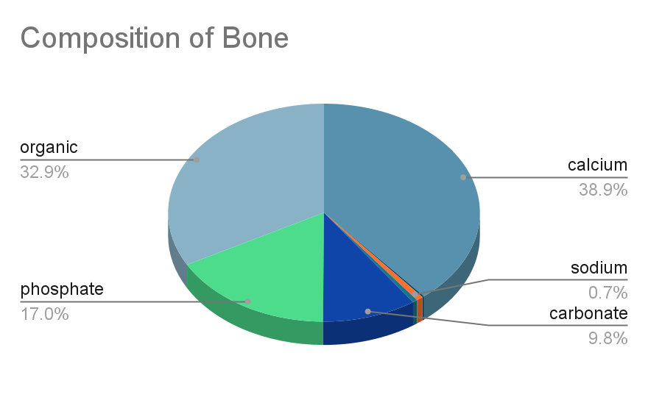
Bone remodeling is a continuous, lifelong process that keeps your bones healthy and strong. It's essentially a two-step dance between specialized cells: removing old or damaged bone and building new bone tissue.
Osteoclasts: These are giant, multi-nucleated cells responsible for breaking down old bone tissue. They dissolve the mineral components of bone and release them back into the bloodstream.
Osteoblasts: These are the bone-building cells. They lay down new bone matrix, a collagen-based scaffold, and then trigger the mineralization process to make the new bone strong.
Osteocytes: These are mature osteoblasts trapped within the bone they helped create. They act as little bone managers, communicating information about stress and strain to help regulate remodeling.
Objectives:- Understanding the common therapies utilized in osteoporosis and the use of the biologicals in management of the osteoporosis
The Remodeling Cycle:
The remodeling cycle can be broken down into three phases:
- Resorption: This phase is initiated by osteoclasts. They attach themselves to the bone surface and secrete enzymes and acids to dissolve the mineral components of the bone. This creates tiny cavities.
- Reversal: This is a short phase where the osteoclasts detach and a new surface is prepared for new bone formation. Special signaling molecules from osteocytes and immune system cells are involved in this transition.
- Formation: Osteoblasts swoop in and fill the cavities created by the osteoclasts. They lay down a collagen-based matrix and then orchestrate the mineralization process, depositing calcium and phosphorus to make the new bone hard and strong.
Importance of Remodeling:
Bone remodeling serves several crucial functions:
- Maintains Bone Strength: By removing old and damaged bone and replacing it with new, healthy tissue, remodeling keeps your bones strong and able to withstand stress.
- Calcium Balance: Remodeling helps regulate calcium levels in the bloodstream. When bone is resorbed, calcium is released back into the blood. During formation, calcium is deposited back into the bone.
- Repair Microdamage: Daily activities can cause tiny cracks in bones. Remodeling helps identify and repair these micro damages before they become bigger problems.
Imbalances in Remodeling:
When the balance between resorption and formation is disrupted, it can lead to bone diseases. For example, if resorption outpaces formation, it can result in osteoporosis, where bones become weak and prone to fractures. Conversely, excessive bone formation can lead to conditions like Paget's disease
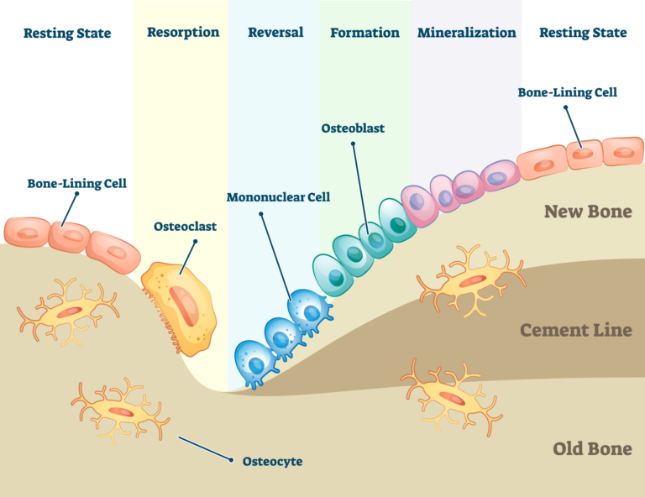

Effects of PTH 1–34 on bone.

Intermittent administration of recombinant human PTH 1–34 stimulates bone formation.

The positive effect of intermittent PTH on bone appears to be mediated through the PTH-1 receptor (PTH1R), expressed only in osteoblasts.
PTH1R activation increases osteoblasts’ number and activity.

However, osteoblast activation by PTH increases the receptor activator of NF-κB ligand (RANK-L) synthesis and decreases osteoprotegerin (OPG) synthesis.

This, in turn, leads to new osteoclasts recruitment
and activation, thus balancing the two processes of bone formation and resorption.

However, the increment in bone formation occurs earlier
than that of bone resorption, thus increasing bone volume in the first months of therapy before osteoclast activation
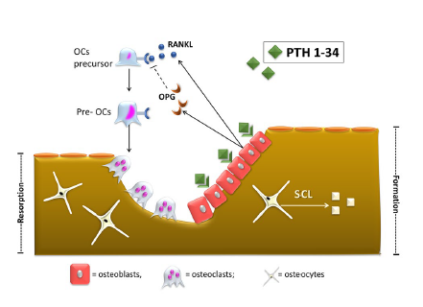
Effects of denosumab on bone.

Denosumab targets and binds the receptor activator of NF-κB ligand (RANK-L) with high affinity and specificity. RANK-L inhibition leads to suppression of osteoclasts differentiation, activity and survival.

The final effect is the reduction of bone resorption sites and increased bone volume
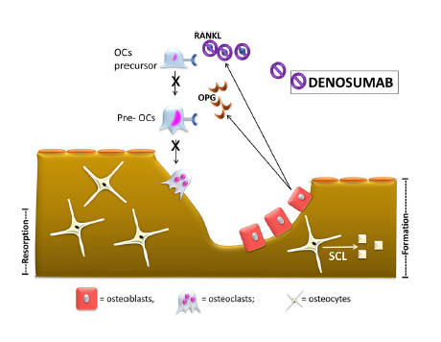
Effects of Romosozumab on bone.

Romosozumab targets and binds sclerostin (Scl). Physiologically, Scl reduces osteoblastogenesis and promotes osteoclastogenesis.

Thus, Scl inhibition leads to both anabolic (increased osteoblast activation) and anti-resorptive (reduced
osteoclastogenesis) effects
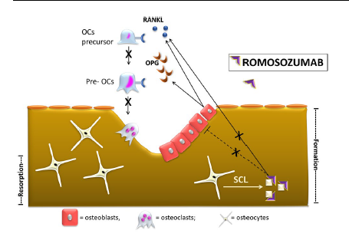
Literature review
Osteoporosis is the most frequent of osteo metabolic diseases and its study has been especially motivated due to the important repercussions in relation to the morbidity and mortality of individuals with this condition, and for this reason it is currently considered a serious public health problem (Lanna, et al. al, 2003). With no symptoms, osteoporosis causes more than 8.9 million fractures annually worldwide, resulting in an osteoporotic fracture every 3 seconds, according to the International Federation of Osteoporosis (IOF). It is estimated that the disease affects 200 million women worldwide, across the planet, one in three women over 50 will suffer osteoporotic fractures, as well as one in five men over 50 years. The few studies carried out with men in Brazil show that the prevalence of the pathology in the male population over 65 years of age is around 15%, while the prevalence of fractures is between 12 and 20%. (Maeda, 2017). Brazil is a country with a great ethnic mixture with heterogeneous regional distribution.
Thus, the prevalence of osteoporosis in Brazilian studies can range from 6 to 33% depending on the population and other variables evaluated (Marinho et al., 2015). It is known that even if osteoporosis occurs in both sexes, women stand out in the development of the disease due to aspects such as the greater number of this population, physiological issues, speed of bone loss, hormonal decrease that impacts on estrogen levels and, the consequent menopausal process (Melo, 2017). In addition, there is the natural factor of advancing age, which also contributes to the higher prevalence of osteopenia and osteoporosis in this population (Mazocco; Chagas, 2017).
According to the Brazilian Society of Endocrinology and Metabolism approximately ten million Brazilians suffer from the disease and one in four women over fifty develops it (Santiago; Vieira; Nunes, 2018). Silva et al. (2018) highlight that one of the consequences of natural or induced ovarian failure is osteoporosis, thus increasing the risk of fractures. Osteoporosis is a major complication of aging in women and is strongly associated with sex hormone deficiency, but it can also be caused by alcoholism or treatment with high doses of corticosteroids. Excess caffeine also has the potential to predispose osteoporosis in postmenopausal patients.
The studies by Hyassat et al. (2017) demonstrated that women at this stage of life with a daily caffeine intake greater than 300 mg/day were at greater risk of developing osteoporosis. Studies have shown that the pathophysiology of the process is based on the direct action of caffeine on osteoblasts and osteocytes, disturbing the process of differentiation, multiplication, mineralization and production of the bone matrix, leading to apoptosis of these cells (Chang, 2013; Liu, 2011). Furthermore, it is mentioned that caffeine can increase the differentiation of osteoclasts, resulting in greater loss of calcium in the urine, a fact that can predispose to the formation of urinary stones (Lacerda, 2010). All of these mechanisms can contribute to the decrease in bone density caused by high caffeine consumption. In addition to menopause, another risk factor that stands out is sarcopenia; such pathology together with osteoporosis consist of diseases that reinforce each other in terms of negative results. With the progressive senescence of the population, there has been a progressive increase in the incidence of musculoskeletal disorders, which corroborates the close association between muscle and bone; it turns out that both are not only tangent adjacent to their anatomical position, they are also known to share common endocrine and paracrine regulation, as well as the pathways that regulate their molecular signaling (Bonewald, et al., 2013; Girgis, 2015). These aspects are relevant because the loss of bone mass, muscle function and strength, when added to the senility process, is significantly enhanced with regard to the occurrence of osteoporotic fractures. Allied to this, age-related decrease in bone mass quality and composition also acts as a sarcopenia maximizer, a fact that proves that both pathologies feedback (Edwards, et al., 2015; Oliveira and Vaz, 2015). Thus, it can be seen that the increased risk of fracture in people with associated osteoporosis and sarcopenia is due to the reduction in muscle strength and mass, as well as the bone mineral density and decreased body mobility (Tarantino, et al., 2016; Steihaug et al., 2017). The work developed by Marques and Queirós (2018) and by Yeung et al. (2019) accused that elderly people with sarcopenia have a triple chance of falling, when compared to those who do not have the pathology in question. Furthermore, there is evidence that sarcopenia is closely linked to fractures, which is aggravated when it occurs in patients with some degree of osteopenia or osteoporosis. Prevention of osteoporosis consists of lifestyle measures and pharmacological therapy taking into account that bone strength reflects the integration of bone mineral density (BMD) and other bone properties that are collectively called "bone quality". Adult BMD is determined by peak bone mass and subsequent bone loss. As the BMD measured by dual energy X-ray absorptiometry (DXA) decreases, the risk of fracture increases as a continuum, without "fracture threshold". Thus, prevention of low bone mass is aimed at maximizing peak bone mass and minimizing the rate of bone loss, with the ultimate goals of maintaining bone strength and preventing fractures (Lewiecki, 2021).
Some authors consider senile osteoporosis a "pediatric disease" taking into account the importance of reaching the maximum peak potential bone mass in childhood in order to lessen the effects of bone loss later in life. Preventing bone loss is preferable to treatment once established pathology has occurred, because the degradation of bone microarchitecture associated with bone loss is largely irreversible. Treatment may stabilize or increase BMD and reduce fracture risk, but is unlikely to fully restore bone quality and bone strength (Kiel, 2021).
The time of peak bone mass is not known with certainty, but it probably occurs in the third decade of life in most individuals. However, for maximum bone mass to be established, good nutrition from childhood is necessary, together with regular physical activities, with the particular benefit of high-impact exercise, associated with a smoking-free life and low-tomoderate alcohol consumption. Furthermore, the administration of medications that are known to be harmful to skeletal health, such as glucocorticoids and anticonvulsants, should be avoided or minimized in dose and duration (Behringer, et al, 2014). As for pharmacological therapy, there is still no means available to maximize peak bone mass, but rather to stabilize bone mineral density and/or reduce the rate of bone loss, which is the main objective in preventing osteoporosis. Lewiecki (2021) considers that the approach to preventing osteoporosis should be done in a pyramid shape, the first level being nutrition, physical activity and prevention of falls, the second level addressing medications and diseases associated with bone loss or osteoporosis and by finally, the third level addressing pharmacological therapy. Age-related bone loss is known to begin shortly after peak bone mass for both sexes. Therefore, for most patients with low bone mass or osteopenia, it is not suggested to use pharmacological therapy to prevent bone loss. With the exception of those patients at high risk of fracture, who will, however, benefit from pharmacological therapy (Rosen; Drezner, 2021).
Based on extensive experience in use, safety and proven efficacy in reducing vertebral, non-vertebral and femoral fractures, bisphosphonates are considered first-line agents in the treatment and prevention of postmenopausal osteoporosis (Caires, et al., 2017). From this class, the most used medications are: alendronate at a dose of 5 mg/day or 35 mg/week; risedronate - 5 mg/day or 35 mg/week; ibandronate - 150 mg/month and zoledronic acid - 5 mg IV once every 2 years. Among the bisphosphonates that have the best cost/benefit, in addition to greater availability of long-term safety data, are alendronate and risedronate, thus becoming the most suitable medications for the prevention of osteoporosis (Rosen, 2021). With regard to alendronate, the prevention dose used is equivalent to half the dose for the treatment, while the prevention and treatment doses are the same for the rest of the bisphosphonates.
Another particularity of application is found in prevention with the use of zoledronic acid, in which the interval of doses for prophylaxis is every two years, and in treatment the dose is annual (Finkelstein; Yu, 2021). Potent antiresorptive agents increase BMD Discontinuation of bisphosphonates after 3 years (zoledronic acid) to 5 years (alendronate) is justified for patients who, at the end of this period, present a low risk of fracture. However, those who persist with a femoral T-score ≤ -2.5 after starting treatment should have this treatment continued for up to 6 (zoledronic acid) to 10 years (alendronate) (Caires et al., 2017). Medications in this class of drugs in young and elderly postmenopausal women have been shown to reduce the risk of fracture in older postmenopausal women. However, Radominski, et al. (2017), reinforce that due to the high prevalence of secondary causes of osteoporosis, many of them subclinical, it is recommended for all patients before starting any treatment a minimum laboratory evaluation that includes complete blood count, calcium, phosphorus, alkaline phosphatase, thyroid function and serum 25(OH) vitamin D measurement, 24-hour calciuria, in addition to plain lateral radiography of the thoracic and lumbar spine and measurement of BMD in the lumbar spine and proximal femur. Another way to prevent osteoporosis is with the use of calcitonin, but it is not used as a first-line therapy due to the fact that there are more effective drugs, such as bisphosphanates. Calcitonin is a 32-amino acid peptide that binds to osteoclasts and inhibits bone resorption. There are calcitonins from several species that have been shown to be compatible with those of humans, as well as human calcitonin; however, the most effective is salmon calcitonin, it has a high affinity (40 times that of human calcitonin) and a slow clearance rate. Currently, the only calcitonin used is human, but numerous clinical trials have shown the best efficacy of salmon calcitonin (Rosen, 2020).
Another way to prevent bone loss, specifically in postmenopausal patients is the use of estrogen, however, it is not a first-line treatment due to concerns about adverse effects. However, in women who chose hormone replacement therapy, estrogen showed reductions in bone loss and fracture risk, in addition to benefits related to menopausal symptoms (Manson, et al, 2013). As for sarcopenia and its relationship with osteoporosis, there are effective measures that can be applied to delay or even reverse the progression of sarcopenia in the elderly. Due to the positive role of resistance exercises in human muscle mass, numerous studies have inserted resistance exercises in the treatment of sarcopenia and, consequently, osteoporosis. Authors demonstrated that a 12- to 16-week cycle of resistance training increased individuals' thigh circumference by 11.4% and muscle volume by 3.8% (Van Roie et al., 2013).
Most interestingly, the authors proved that muscle growth caused by resistance exercise can occur at any age, even in the elderly (Westcott, 2009). In addition to resistance exercise, exercise in water can improve muscle balance and muscle strength, in addition to providing adequate postural mobility (Irandoust, et al., 2019). Regular physical activity can act on the clearance of body fat, improve musculoskeletal control, reduce low back pain, and improve the quality of balance and walking speed in the elderly (Irandoust, et al., 2019). Similarly, Pilates exercise can increase body fat mass and improve muscle atrophy, balance, and walking speed in middle-aged inactive women (Seghatoleslami, et al., 2018). Skeletal muscle atrophy and skeletal muscle strength have been shown to significantly improve in elderly patients with sarcopenia after adequate treatment with vitamin D and amino acids (Seeliger, et al., 2015).
Authors have pointed out that combining resistance exercise with protein and vitamin D supplements is the most effective way to improve sarcopenia or myasthenia in the elderly (Eshaghi, et al., 2020). However, the complex pathogenesis of sarcopenia and several influencing factors have not been fully understood. Regarding how food can help in the osteoporotic prevention process, the Mediterranean Food Pattern or Mediterranean Diet (DM) has beneficial effects on many pathologies, including osteoporosis. The incidence of osteoporosis is lower in the Mediterranean area, which is mostly attributed to the specific dietary pattern of the area. The anti-inflammatory, antioxidant and alkalizing properties of its components contribute to the “bone-sparing” effect. Some studies demonstrate that adherence to traditional DM has been associated with high bone mineral density and reduced fracture risk. Thus, an association between key individual characteristics of the Mediterranean Food Pattern and a reduction in the incidence of osteoporosis or fracture occurrence is demonstrated, such as high consumption of fruit, vegetables and olive oil, moderate to high consumption of fish and moderate intake of alcoholic beverages (Almeida, 2017). The study by Savanelli (2017) showed a positive correlation between bone health status and adherence to DM.

Methodology

Study Design
This study employed a cross-sectional survey design to assess the preferences and practices of physicians in Mumbai regarding the management of osteoporosis. A structured questionnaire was developed to collect quantitative data on the use of conventional therapies (such as calcium and vitamin D3) and biological treatments (such as denosumab and teriparatide).

Participants
The study targeted physicians in Mumbai who are actively involved in the treatment of osteoporosis. A convenience sampling method was used to select participants, aiming to capture a diverse range of practices and preferences within the local medical community. A total of 47 physicians agreed to participate in the survey.

Data Collection
Data were collected using a self-administered questionnaire distributed electronically and in person between January 2024 and April 2024. The questionnaire was designed to be comprehensive yet concise, ensuring ease of completion while capturing essential information on treatment practices. Key sections of the questionnaire included:
- Demographic information: Age, gender, years of practice, and specialty.
- Conventional therapies: Frequency and rationale for using calcium and vitamin D3 supplements.
- Biological treatments: Frequency and rationale for using denosumab and teriparatide.
- Other treatments: Use of bisphosphonates and other relevant medications.
- Factors influencing treatment choices: Clinical guidelines, patient preferences, and perceived efficacy and safety of treatments.

Data Analysis
Data were analyzed using descriptive statistics to summarize the frequencies and percentages of different treatment practices. Comparative analyses were performed to identify patterns and correlations between physician demographics and their treatment preferences. Statistical software (e.g., SPSS, R) was used to ensure accurate and reliable analysis of the survey data.

Ethical Considerations
The study was conducted in accordance with ethical standards and guidelines for research involving human participants. Informed consent was obtained from all participants prior to their involvement in the survey. Confidentiality and anonymity of the respondents were maintained throughout the study, with data being securely stored and accessible only to the research team.

Limitations
While the study provides valuable insights into the management of osteoporosis among physicians in Mumbai, it is not without limitations. The convenience sampling method may introduce selection bias, as it depends on the availability and willingness of physicians to participate. The sample size of 47 physicians, although informative, may not fully represent the broader population of healthcare providers in Mumbai or other regions.
Additionally, the reliance on self-reported data may result in reporting bias, where participants might overestimate or underestimate their actual practices. Future studies should consider larger, randomized samples and potentially incorporate additional qualitative methods to gain deeper insights into the reasons behind treatment choices.

Statistical analysis :
Descriptive statistics
Total doctors surveyed:47
Total doctors using denosumab:29
Total doctors using teriparatide 35
Total doctors using calcium:39
Total doctors using nsaids:13
Total doctors using vitamin D3:39
Total doctors using bisphosphate oral:17
Total doctors using bisphosphonate :14
Percentage of doctors using therapy was calculated by the following formulas:

Percent of doctors using denosumab: 61.70%
Percent of doctors using teriparatide :74.46%
Percent of doctors using calcium:82.97%
Percent of doctors using nsaids:27.65%
Percent of doctors using vitamin D3: 82.97%
Percent of doctors using bisphosphonate oral : 36.17%
Percent of doctors using bisphosphonate IV : 29.78%

Hypothesis testing
Null Hypothesis (H0​): The proportion of doctors using denosumab (p1​) is equal to the proportion of doctors using teriparatide (p2​).
H₀​:p1​=p2​

Alternative Hypothesis (HA​): The proportion of doctors using denosumab (p1​) is not equal to the proportion of doctors using teriparatide (p2​)
H_{A}​:p1​≠p2​

- Calculate sample proportion
- Proportion of doctors using denosumab:
𝑝1^=29/47
- Proportion of doctors using teriparatide:
𝑝2^=35/47
Calculate the Test Statistic:
Use a two-proportion z-test for this analysis. The formula for the test statistic 𝑧 is:

where p̂​ is the pooled sample proportion:

x1​=29, 𝑛1=47
𝑥2=35, 𝑛2=47
Calculate 𝑝̂

Calculate the standard error (SE):

Calculate the z value

Determine the p-value
the z-value in the standard normal distribution table to find the p-value. For 𝑧=−2.175 the p-value is approximately 0.0296 (two-tailed test).
p-value to the significance level (𝛼). If 𝛼=0.05:
If 𝑝≤0.05, reject the null hypothesis.
If 𝑝>0.05, do not reject the null hypothesis.
In this case, 𝑝=0.0296 which is less than 0.05, so we reject the null hypothesis.
Result:
There is sufficient evidence to conclude that the proportions of doctors using denosumab and teriparatide are significantly different. Specifically, fewer doctors use denosumab compared to teriparatide.
The common therapies utilized were found to be vitamin d3 and calcium in conventional therapies and the teriparatide in the biologicals.
Calcium and the vitamin d3 was found to be 82.97% and teriparatide was found to be 74.46%
Discussion:

Discussion

Interpretation of Results
The results of this survey highlight the current preferences and practices among physicians in Mumbai regarding the management of osteoporosis. A significant proportion of doctors prefer using conventional therapies such as calcium (82.97%) and vitamin D3 (82.97%), indicating a strong reliance on these well-established treatments. The high usage rates of these supplements align with their known benefits in improving bone health and preventing osteoporosis-related fractures.
Biological therapies, represented by denosumab and teriparatide, are also widely used, with 61.70% and 74.46% of doctors, respectively, incorporating them into their treatment regimens. This reflects a growing acceptance of biologicals in clinical practice, likely due to their efficacy in reducing fracture risk and increasing bone mineral density. The preference for teriparatide over denosumab may be attributed to its anabolic effects, which can be particularly beneficial in severe cases of osteoporosis.
The use of bisphosphonates, both oral (36.17%) and IV (29.78%), suggests that while they remain a staple in osteoporosis management, their use is less prevalent compared to calcium, vitamin D3, and biologicals. This could be due to concerns about long-term safety and the side effect profiles of bisphosphonates, which may limit their use in certain patient populations.

Comparison with Existing Literature
The findings of this study are consistent with global trends in osteoporosis management. Studies have shown that calcium and vitamin D3 are fundamental components of osteoporosis prevention and treatment strategies, supporting bone health and reducing fracture risk (Lewiecki, 2021). The use of biologicals like denosumab and teriparatide has been increasing worldwide, reflecting their proven effectiveness in clinical trials and real-world settings (Rosen, 2021).
The relatively lower usage of bisphosphonates compared to calcium, vitamin D3, and biologicals may be influenced by recent guidelines and studies emphasizing the importance of balancing efficacy with potential adverse effects, such as osteonecrosis of the jaw and atypical femoral fractures associated with long-term bisphosphonate use (Finkelstein & Yu, 2021).

Implications for Practice
These results suggest that physicians in Mumbai are aligning their practices with current evidence-based guidelines, favoring treatments that offer the best balance of efficacy and safety. The high usage rates of calcium and vitamin D3 indicate a strong emphasis on foundational therapies, while the significant use of biologicals highlights an openness to newer, effective treatment options.
For policymakers and healthcare providers, these insights underscore the importance of ensuring access to a range of osteoporosis treatments, including both conventional supplements and advanced biologicals. Education and training programs should continue to update healthcare professionals on the latest evidence and best practices in osteoporosis management.

Limitations
This study has several limitations that should be considered when interpreting the results. The sample size was limited to 47 physicians, which may not fully represent the broader population of healthcare providers in Mumbai or other regions. The convenience sampling method, while practical, may introduce selection bias, as it relies on the availability and willingness of participating doctors.
Additionally, the survey data is based on self-reported practices, which may be subject to reporting bias or inaccuracies. Future research could benefit from larger, randomized studies to validate these findings and explore additional factors influencing treatment choices.

Conclusion
The management of osteoporosis among physicians in Mumbai reflects a balanced approach, integrating both conventional therapies and biologicals. The preferences observed in this study are consistent with current clinical guidelines and global trends, highlighting the ongoing evolution in osteoporosis treatment practices. Addressing the limitations of this study through further research will enhance our understanding and support the development of optimized strategies for osteoporosis management

